ADVANCED CYBERSECURITY CONCEPTS

TASK

TASK1: Draw a simple network diagram for a food delivery app backend (like Zomato), showing at least 3 segments: public web servers, application servers, and a database server. Clearly label each segment and show how they connect.
Step 1: Understand the three network segments
A food delivery application like Zomato needs different servers to handle customer requests, process application operations, and store information.
Segment | Purpose
1. Public Web Servers | Receive requests from customers using the website or app.
2. Application Servers | Process orders, manage restaurants, and handle delivery requests.
3. Database Server | Stores customer details, restaurant information, orders, and delivery records.

Step 2: Draw the network diagram

Step 3: Understand how it works
- Customers open the food delivery application.
- Public web servers receive their requests.
- Application servers process orders and restaurant information.
- The application servers request required information from the database.
- The database sends the requested information back through the application servers.

TASK2: Design a network segmentation plan for an online ticket booking system (like BookMyShow) using VLANs or subnets. Specify which types of devices/services go in each segment and explain how segmentation improves security.<br><br><em><strong>Hint:</strong> Think about separating user-facing services, payment processing, and admin management.</em>
Step 1: What is network segmentation?
Network segmentation means dividing a large network into smaller separate networks.
For an online ticket booking application like BookMyShow, we can create separate VLANs for different services.

Step 2: Create the segmentation plan
VLAN | Segment name | Devices / Services | Example subnet
VLAN 10 | User Services | Website and customer-facing servers | 192.168.10.0/24
VLAN 20 | Application Services | Ticket booking and seat management servers | 192.168.20.0/24
VLAN 30 | Payment Services | Payment processing servers | 192.168.30.0/24
VLAN 40 | Database Services | Customer and booking databases | 192.168.40.0/24
VLAN 50 | Admin Management | Employee computers and management systems | 192.168.50.0/24

Step 3: Draw the network diagram
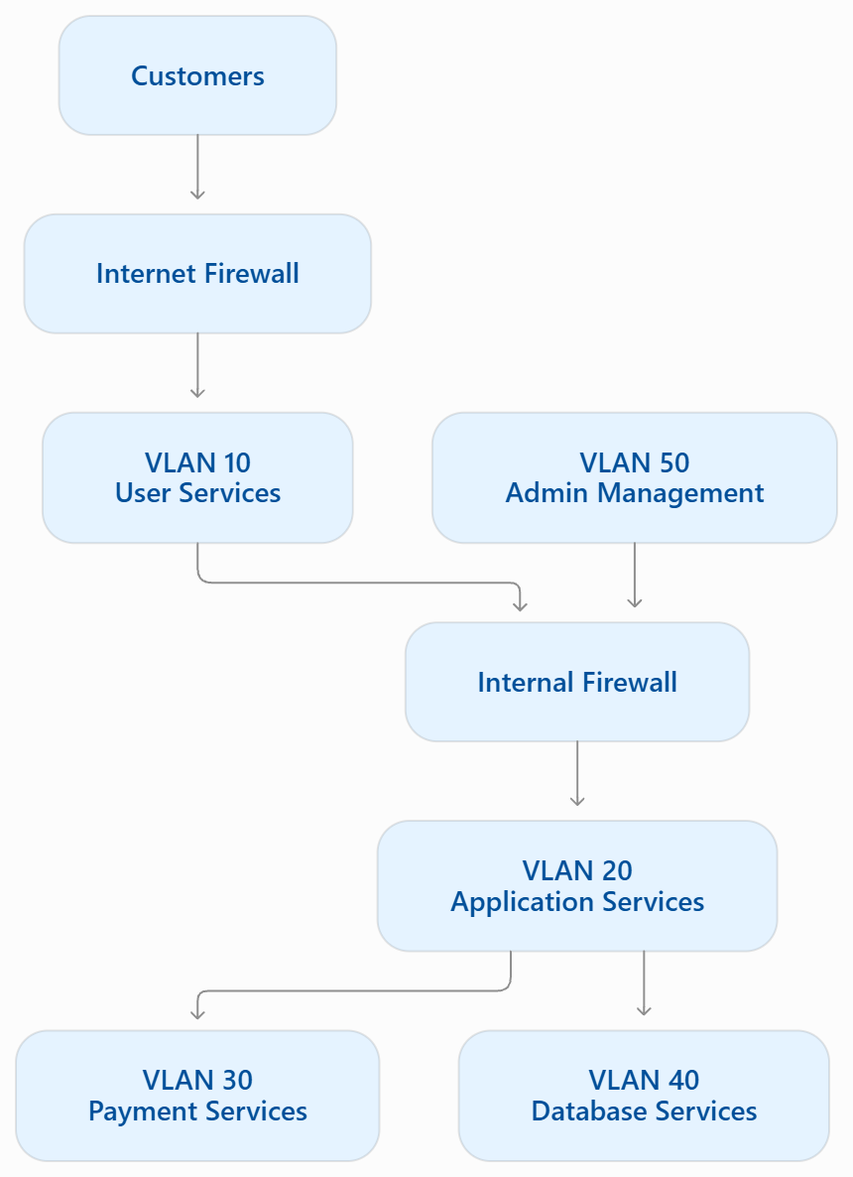
Step 4: Explain how segmentation improves security
- Payment protection: Payment systems are separated from public-facing services.
- Database protection: Customer and booking information is not directly exposed to the internet.
- Admin protection: Only authorized employees can access management systems.
- Limited attack spread: If one segment is attacked, the attacker cannot automatically access every other segment.

TASK3: Choose and place an IDS or IPS (such as Snort or Suricata) in your network design for a music streaming service (like Spotify). Explain where you would deploy it and what type of attacks it should detect or block.
Step 1: Understand IDS and IPS
System | Full form | Work
IDS | Intrusion Detection System | Monitors network traffic and generates alerts when suspicious activity is detected.
IPS | Intrusion Prevention System | Monitors network traffic and can block suspicious activity automatically.
EXAMPLE TOOLS : SNORT AND SURICATA
Step 2: Where should we place the IDS/IPS?
For a music streaming service like Spotify, I would place an IDS/IPS between the firewall and the application server network. I would also monitor traffic going towards the database segment.

Step 3: What attacks should it detect or block?
Attack | What it does
Port Scanning | Searches for open ports and services.
SQL Injection | Attempts to manipulate database queries.
DoS Attacks | Sends excessive requests to make a service unavailable.
Brute-Force Attacks | Repeatedly tries passwords to access an account.
Malware Traffic | Detects suspicious communication from infected devices.
Step 4: How does it work?
- Users send requests to the music streaming service.
- The firewall filters incoming network traffic.
- The IDS/IPS checks the traffic for suspicious activity.
- The IDS generates alerts, or the IPS blocks matching malicious traffic.
- The application servers and database receive only permitted traffic.

TASK4: Review a peer's network segmentation and IDS/IPS placement for their chosen app scenario. Suggest two improvements to make their design more secure or efficient.<br><br><em><strong>Hint:</strong> Consider if sensitive data is properly isolated and if monitoring covers all critical segments.</em>
Step 1: What is peer review?
Peer review means checking another student's network diagram and identifying possible security improvements.
You should check:
- Whether sensitive data is properly separated.
- Whether firewalls are placed correctly.
- Whether the IDS/IPS monitors important network traffic.
- Whether unauthorized users can access restricted segments.
Step 2: Suggest two improvements
Improvement 1: Separate sensitive data
Payment information and customer databases should be placed in separate network segments. Only authorized application servers should access them.
Benefit: It reduces the chance of attackers accessing all sensitive information if one segment is compromised.
Improvement 2: Improve IDS/IPS monitoring
Place an IDS/IPS near the network entry point and monitor important internal connections, especially application-to-database traffic.
Benefit: It helps detect suspicious traffic and attacks moving between network segments.

TASK5: After your review session, update your own network diagram and write a short note on one change you made based on feedback or discussion.
Step 1: Make changes to your original diagram
Return to your Task 1 food delivery network diagram.
Add these improvements:
- Add a separate database firewall between the application server and database.
- Add an IDS/IPS near the internet firewall to monitor incoming traffic.
- Restrict database access to authorized application servers only.
Step 2: Updated network diagram
Change Made After Peer Review
After the review session, I updated my original food delivery network diagram. I added an IDS/IPS after the internet firewall to monitor incoming traffic. I also added an internal firewall between the application servers and database server.
These changes help detect suspicious activities, restrict unauthorized database access, and improve the overall security of the network.

